# CIS7 Unit 10 Rev 1 In-Class Assignment: Graphs and Vertices

1. Refer to below graph and identify the following:
2. Vertices {A, B, C, D, E, F, G}
3. Edges {B, G}, {B, A}, {A, E}, {A, F}, {A, C}, {A, B}, {C, F}, {C, D}, {C, A}, {D, C}, {D, E} {E, A}, {E, G},

{E, D}, {E, F}, {F, E}, {F, G}, {F, C}, {F, A}, {G, E}, {G, B}, {G, F}

1. Degree of vertices

A, E, F have degree of 4.

C, G have degree of 3.

B, D have degree of 2.

1. Adjacent and non-adjacent vertices.

A adjacent to E, F, C, B

A non-adjacent to G, D

B adjacent to A, G

B non-adjacent to E, F, C, D

C adjacent to A, F, D

C non-adjacent to E, B, G

D adjacent to C, E

D non-adjacent to F, A, G, B

E adjacent to A, D, F, G

E non-adjacent to B, C

F adjacent to E, G, C, A

F non-adjacent to D, B

G adjacent to B, E, F

G non-adjacent to A, C, D

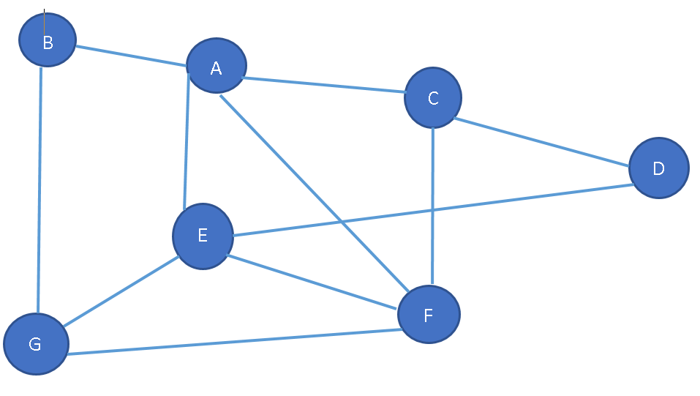

1. Refer to Exercise 1 graph, note the degrees of vertices in the graph.

A, E, F have degree of 4.

C, G have degree of 3.

B, D have degree of 2.

1. Refer to Exercise 1 graph, identify the paths of each vertex in the graph.

**Simple Path**: {B, G}, {B, A, E, G}, {A, E, F, C, D}, {A, C, D, E, G}, {C, F, E, A, B}

**Cycle:** {B, G, E, D, C, A, B}, {A, C, D, E, A}, {E, F, G, E}

**Long Path**: {B, A, C, D, E, A, F, G, E, F, G}

1. Refer to below graph, and identify the following:
2. Vertices {A, B, C, D, E, F, G}
3. Edges {A, F}, {A, E}, {A, B}, {A, G}, {B, G}, {C, D}, {E, F}, {E, G}, {G, F}
4. Degree of the vertices

A, G have degree 4.

E, F have degree 3.

B has degree 2.

C, D have degree 1

1. Adjacent and non-adjacent vertices

A adjacent to B, E, F, G

A non-adjacent to C, D

B adjacent to A, G

B non-adjacent to C, D, E, F

C adjacent to D

C non-adjacent to A, B, E, F, G

D adjacent to C

D non-adjacent to A, B, E, F, G

E adjacent to A, F, G

E non-adjacent to B, C, D

F adjacent to A, E, G

F non-adjacent to B, C, D

G adjacent to A, B, E, F

G non-adjacent to C, D

1. Paths, no path and simple paths.

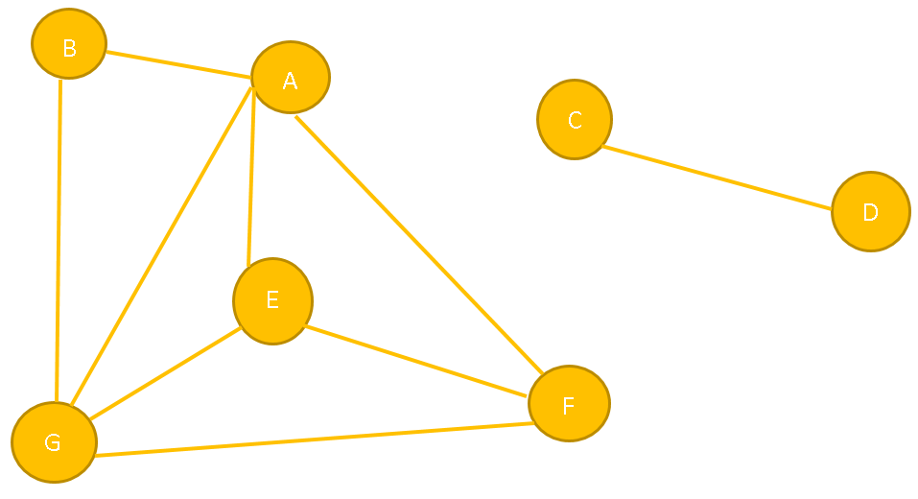

**Simple Paths**: {B, A, F, E, G}, {C, D}, {A, G, F}, {G, A, B}

**Cycle**: {B, A, F, E, G, B}, {A, G, E, F, A}, {E, G, F, E}

**No Path**: {C, F}, {C, A}, {C, B}, {C, G}, {C, E}, {D, F}, {D, A}, {D, B}, {D,G}, {D, E}

**Long Path**: {B, A, G, E, G, A, E, F}

1. Refer to below graph and identify the cycles in the graph (yellow paths).
   1. Vertices {A, B, C, D, E, F, G}
   2. Edges {A, B}, {A, E}, {A, G}, {B, G}, {E, G}, {E, F}, {F, A}, {C, F}, {C, D}, {F, D}, {F, G}
   3. Degree of the vertices

F has degree 5.

A, G have degree 4.

E has degree 3.

B, C, D have degree 2.

* 1. Adjacent and non-adjacent vertices

A adjacent to B, E, F, G

A non-adjacent to C, D

B adjacent to A, G

B non-adjacent to C, D, E, F

C adjacent to D, F

C non-adjacent to A, B, E, G

D adjacent to C, F

D non-adjacent to A, B, E, G

E adjacent to A, F, G

E non-adjacent to B, C, D

F adjacent to A, C, D, E, G

F non-adjacent to B

G adjacent to A, B, E, F

G non-adjacent to C, D

* 1. Paths, no path and simple paths.

**Simple Path:** {A, E, F}

**No Path:** {A, C}

**Long Path:** {A, B, G, A, B, G, F}

* 1. Cycles

{A, E, F, A}

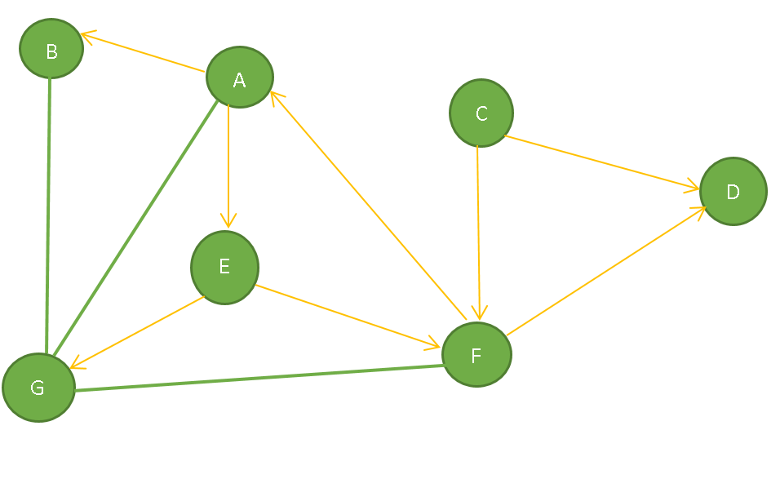

1. Refer to below simple graph and create its adjacency list.

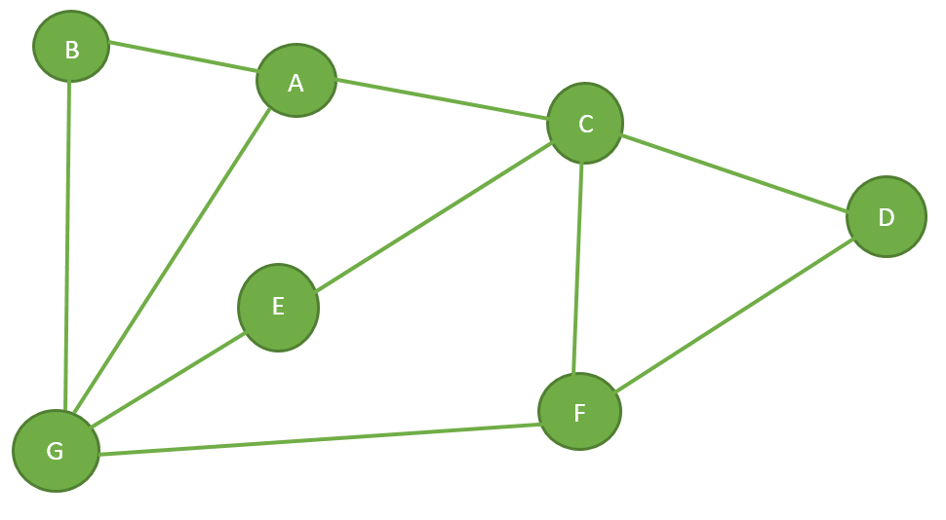

|  |  |  |  |  |  |  |  |
| --- | --- | --- | --- | --- | --- | --- | --- |
| Vertex | A | B | C | D | E | F | G |
| A | 0 | 1 | 1 | 0 | 0 | 0 | 1 |
| B | 1 | 0 | 0 | 0 | 0 | 0 | 1 |
| C | 1 | 0 | 0 | 1 | 1 | 1 | 0 |
| D | 0 | 0 | 1 | 0 | 0 | 1 | 0 |
| E | 0 | 0 | 1 | 0 | 0 | 0 | 1 |
| F | 0 | 0 | 1 | 1 | 0 | 0 | 1 |
| G | 1 | 1 | 0 | 0 | 1 | 1 | 0 |

1. Refer to below weighted graph and determine its adjacency list.

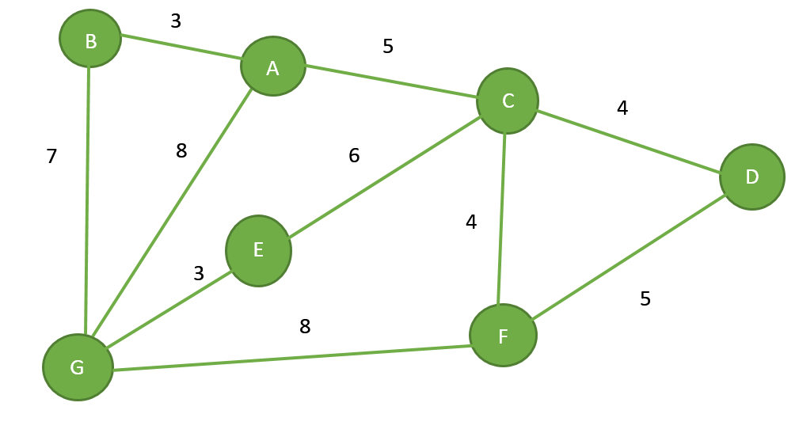

|  |  |  |  |  |  |  |  |
| --- | --- | --- | --- | --- | --- | --- | --- |
| Vertex | A | B | C | D | E | F | G |
| A | 0 | 3 | 5 | 0 | 0 | 0 | 8 |
| B | 3 | 0 | 0 | 0 | 0 | 0 | 7 |
| C | 5 | 0 | 0 | 4 | 6 | 4 | 0 |
| D | 0 | 0 | 4 | 0 | 0 | 5 | 0 |
| E | 0 | 0 | 6 | 0 | 0 | 0 | 3 |
| F | 0 | 0 | 4 | 5 | 0 | 0 | 8 |
| G | 8 | 7 | 0 | 0 | 3 | 8 | 0 |

1. Create the adjacency matrix based on the below graph.

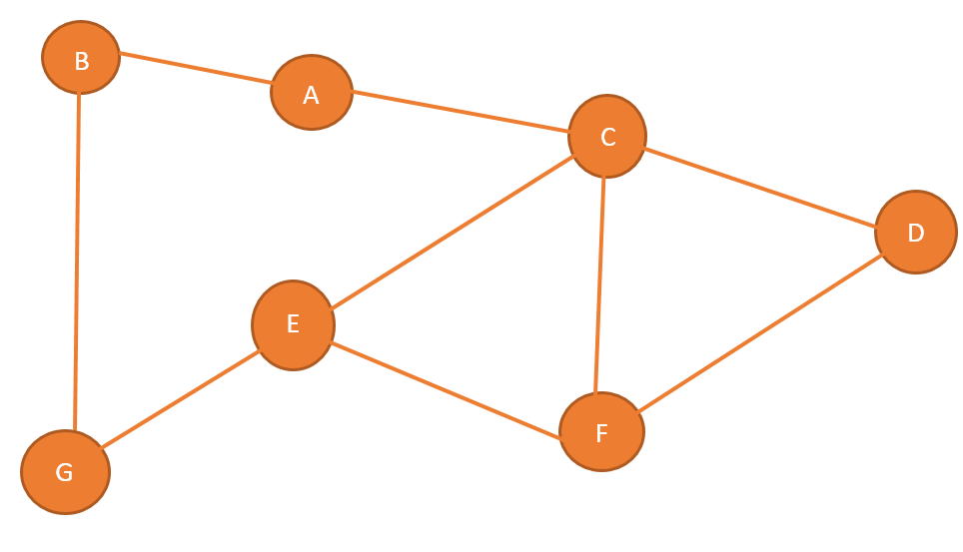

|  |  |  |  |  |  |  |  |
| --- | --- | --- | --- | --- | --- | --- | --- |
| Vertex | A | B | C | D | E | F | G |
| A | 0 | 1 | 1 | 0 | 0 | 0 | 0 |
| B | 1 | 0 | 0 | 0 | 0 | 0 | 1 |
| C | 1 | 0 | 0 | 1 | 1 | 1 | 0 |
| D | 0 | 0 | 1 | 0 | 0 | 1 | 0 |
| E | 0 | 0 | 1 | 0 | 0 | 1 | 1 |
| F | 0 | 0 | 1 | 1 | 1 | 0 | 0 |
| G | 0 | 1 | 0 | 0 | 1 | 0 | 0 |

1. Create adjacency matrix based on the below weighted graph.

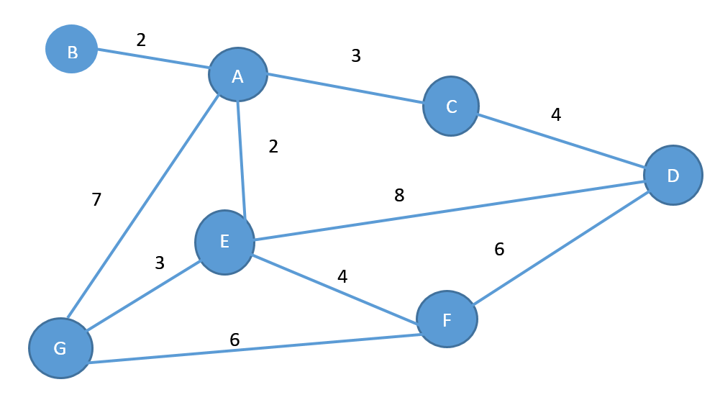

|  |  |  |  |  |  |  |  |
| --- | --- | --- | --- | --- | --- | --- | --- |
| Vertex | A | B | C | D | E | F | G |
| A | 0 | 2 | 3 | 0 | 2 | 0 | 7 |
| B | 2 | 0 | 0 | 0 | 0 | 0 | 0 |
| C | 3 | 0 | 0 | 4 | 0 | 0 | 0 |
| D | 0 | 0 | 4 | 0 | 8 | 6 | 0 |
| E | 2 | 0 | 0 | 8 | 0 | 4 | 3 |
| F | 0 | 0 | 0 | 6 | 4 | 0 | 6 |
| G | 7 | 0 | 0 | 0 | 3 | 6 | 0 |

1. Identify the depth first traversal paths based on the node’s adjacency list using the below graph.

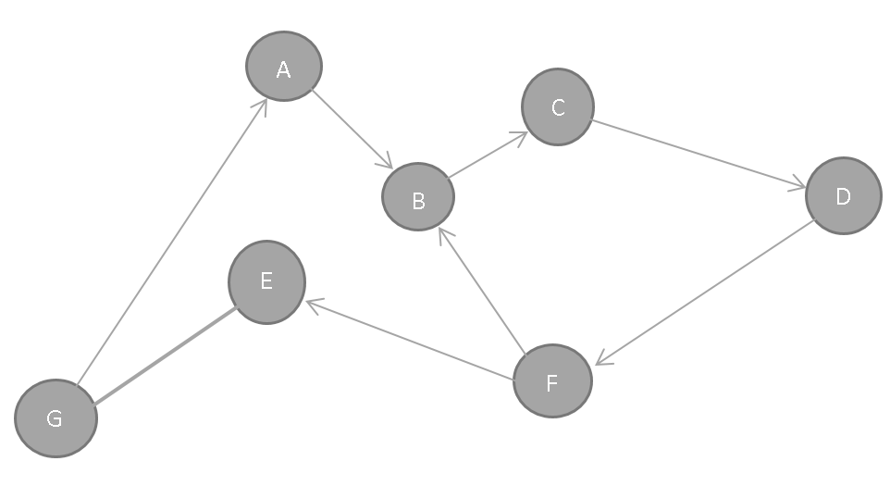

**From G to E:**

DFS Path: {G, A, B, C, D, F, E}

BFS Path: {G, A, @G, E, @A, B, C, D, F}

1. Using the below graph, complete the following tasks:
   1. Illustrate the breadth first traversal starting at vertex F.

BFS Path: {F, B, @F, E, @B, C, D, @E, B}

* 1. Illustrate any path in the graph.

{F, E, B, C, D}

* 1. Demonstrate the use of shortest path

**Shortest Path from F to D:** {F, B, C, D}

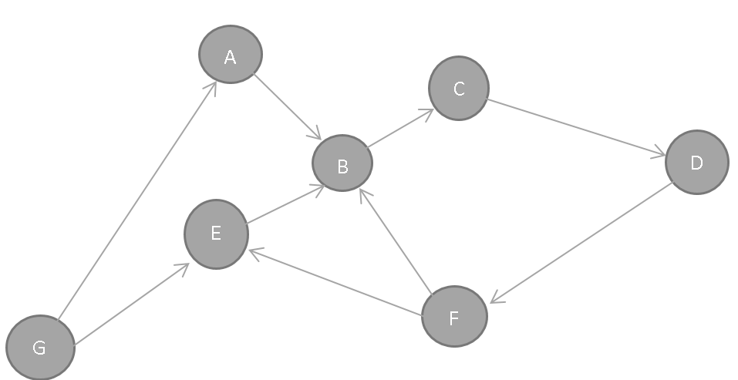

1. Determine the cheapest path for the below graph.

**Cheapest Path From F to B:**

{F, E, A, B} -> 4 + 2 + 2 = 8

{F, G, A, B} -> 6 + 7 + 2 = 15

{F, D, C, A, B} -> 6 + 4 + 3 + 2 = 15

{F, E, D, C, A, B} -> 4 + 8 + 4 + 3 + 2 = 21

